Idris Ratlamwala

C31 - 2003145

Experiment 6: Programs on Two Dimensional Arrays

**Theory :**

The simplest of the multi-dimensional array is a **two-dimensional array**.

A simple definition of 2D arrays is: A 2D array is an array of one-dimensional arrays.

In Java, a two-dimensional array is stored in the form of rows and columns and is represented in the form of a matrix.

**The general declaration of a two-dimensional array is,**

data_type [] [] array_name;

Here,

data_type = data type of elements that will be stored in an array.  
array_name = name of the two-dimensional array.

**A 2D array can be created using new as follows:**

data_type[][] array_name = new data_type[row_size][column_size];

Here,

row_size = number of rows an array will contain.  
column_size = number of columns array will contain.

An integer array named ‘myarray’ of 3 rows and 2 columns can be declared as below.

int [][] myarray = new int[3][2];

**Initialize 2d Array**

Similar to 1D array, 2 nested for loops can be used to initialize a 2d array.

for(int i=0;i<3;i++) for(int j=0;j<2;j++) myarray[i][j]=sc.nextInt();

**A.**

**Aim :** WAP to find Transpose of a Matrix (One class ,only main).

**Program :**

        import java.util.Scanner;

    public class Transpose {

        public static void main(String[] args) {

            Scanner sc = new Scanner(System.in);

            System.out.print("Enter the number of rows and column in matrix :");

            int m=sc.nextInt();

            int n=sc.nextInt();

            int[][] a= new int[m][n];

            int[][] b= new int[n][m];

            System.out.println("Enter the elements of matrix :");

            for(int i=0;i<m;i++) for(int j=0;j<n;j++) a[i][j]=sc.nextInt();

            System.out.println("Transposed matrix :");

            for(int i=0;i<m;i++) for(int j=0;j<n;j++) b[j][i]=a[i][j];

            for(int i=0;i<n;i++) {

                for(int j=0;j<m;j++)

                System.out.print(b[i][j]+" ");

                System.out.println();

            }

        }

    }

**Output :**

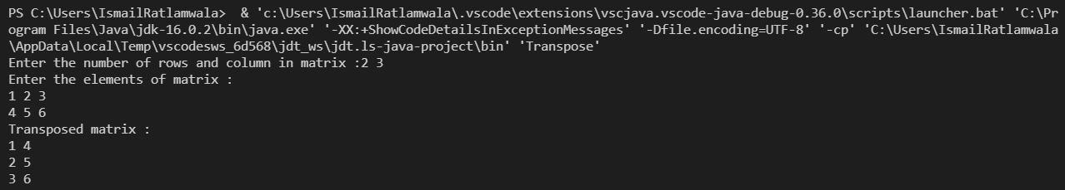

**B.**

**Aim :** WAP to Pass a 2D Matrix to a function which determines if it is a square matrix. If not, program should come to end else the program should find sum of all diagonal elements of a Matrix.

**Program :**

        import java.util.Scanner;

    public class sumOfDiagonal {

        public static int sum(int a[][]) {

            if(a.length==a[0].length){

                int sum=0;

                for(int i=0;i<a.length;i++)

                for(int j=0;j<a[0].length;j++)

                sum=(i==j)?(sum+a[i][j]):sum;

                return sum;

            }

            return -1;

        }

        public static void main(String[] args) {

            Scanner sc = new Scanner(System.in);

            System.out.print("Enter the number of rows and column in matrix :");

            int m=sc.nextInt();

            int n=sc.nextInt();

            int[][] a= new int[m][n];

            System.out.println("Enter the elements of matrix :");

            for(int i=0;i<m;i++) for(int j=0;j<n;j++) a[i][j]=sc.nextInt();

            int sum=sum(a);

            if(sum==-1) System.out.println("Given matrix is not a square matrix");

            else System.out.println("Sum of diagonal elements : "+sum);

        }

    }

**Output** :

